Steps to install Ranger

1. Install any database on the node, I am using Mysql database:

**yum -y install mysql-server**

1. Start, Config and Connect to the mysql database:

**sudo service mysqld start**

**/usr/bin/mysqladmin -u root password admin**

**mysql -u root -p**

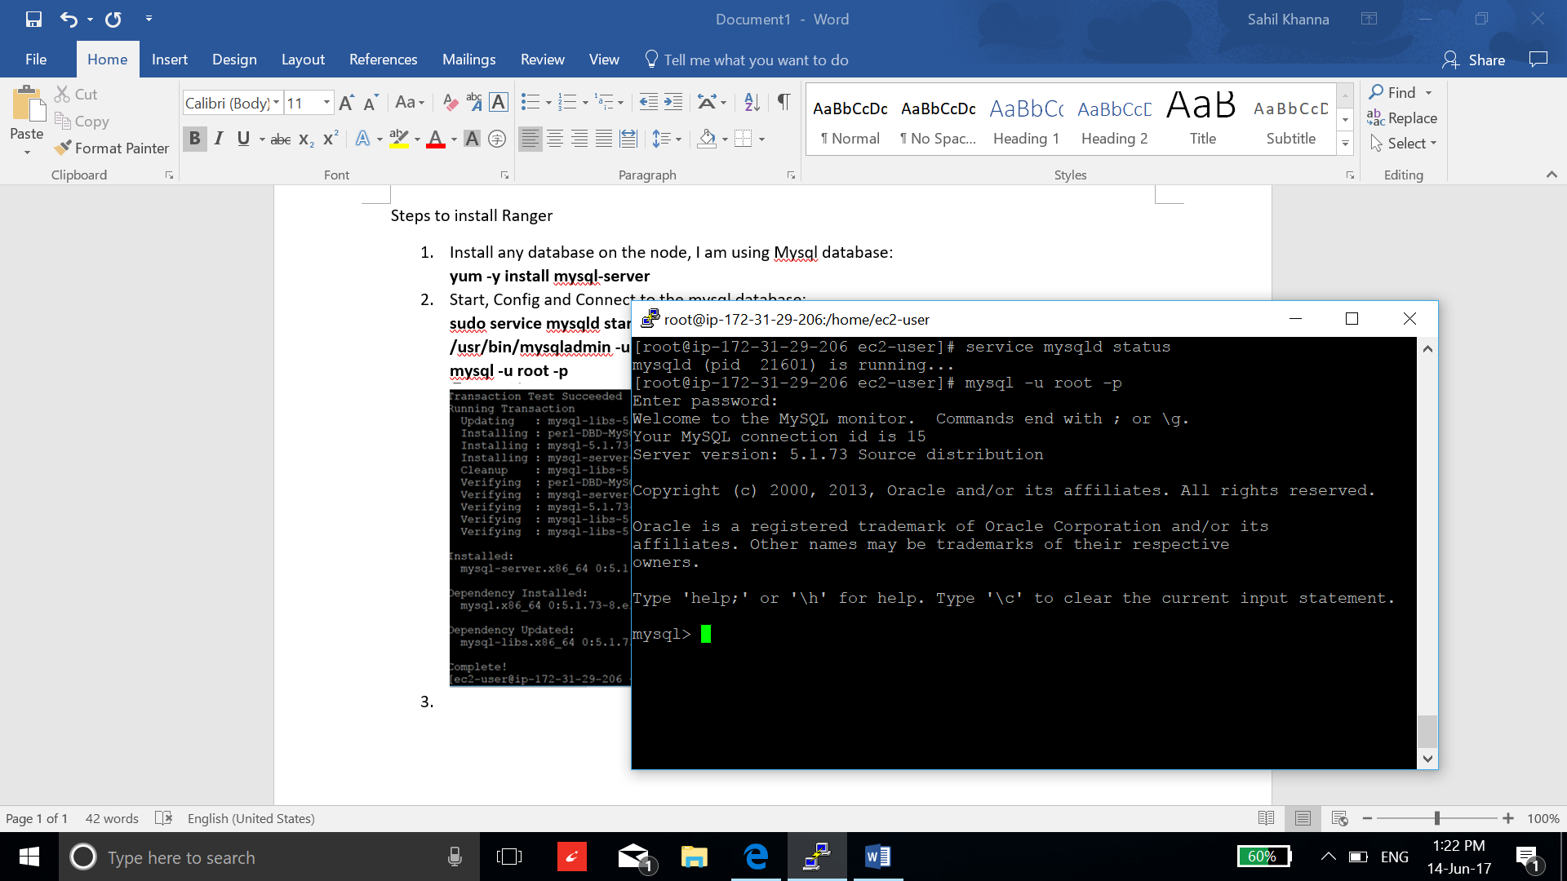

1. Execute following commands to configure my sql:

**CREATE USER 'rangerdba'@'localhost' IDENTIFIED BY 'rangerdba';**

**GRANT ALL PRIVILEGES ON *.* TO 'rangerdba'@'localhost';**

**CREATE USER 'rangerdba'@'%' IDENTIFIED BY 'rangerdba';**

**GRANT ALL PRIVILEGES ON *.* TO 'rangerdba'@'%';**

**GRANT ALL PRIVILEGES ON *.* TO 'rangerdba'@'localhost' WITH GRANT OPTION;**

**GRANT ALL PRIVILEGES ON *.* TO 'rangerdba'@'%' WITH GRANT OPTION;**

**FLUSH PRIVILEGES;**

1. Install the mysql jar file:

**yum install mysql-connector-java\***

**ls /usr/share/java/mysql-connector-java.jar**

1. Format the jdbc drivers:

**ambari-server setup --jdbc-db=mysql --jdbc-driver=/usr/share/java/mysql-connector-java.jar**

1. Now add ranger service from the Ambari user interface and select next.

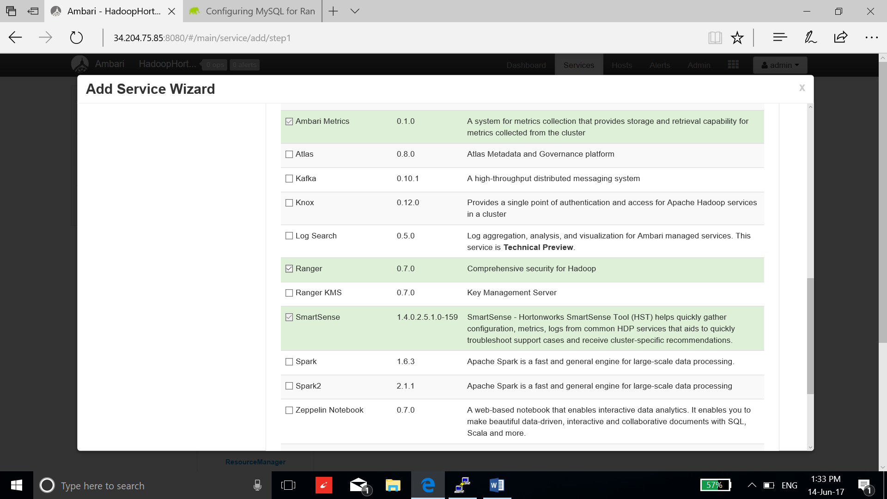

1. Acknowledge the minimum requirement completion and select proceed:

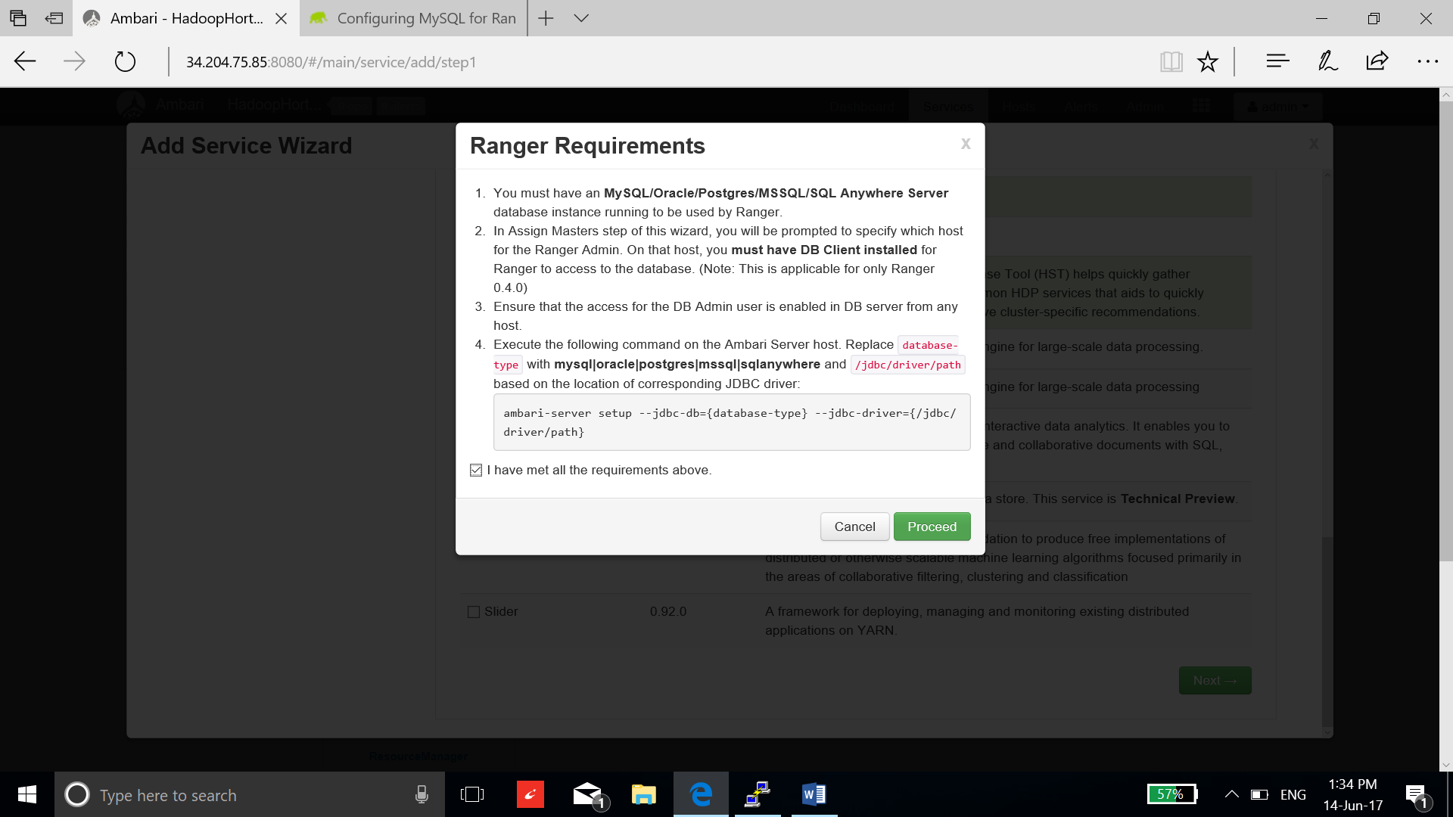

1. Now use the default settings until configuration page. Fill the configuration using the below screenshot.

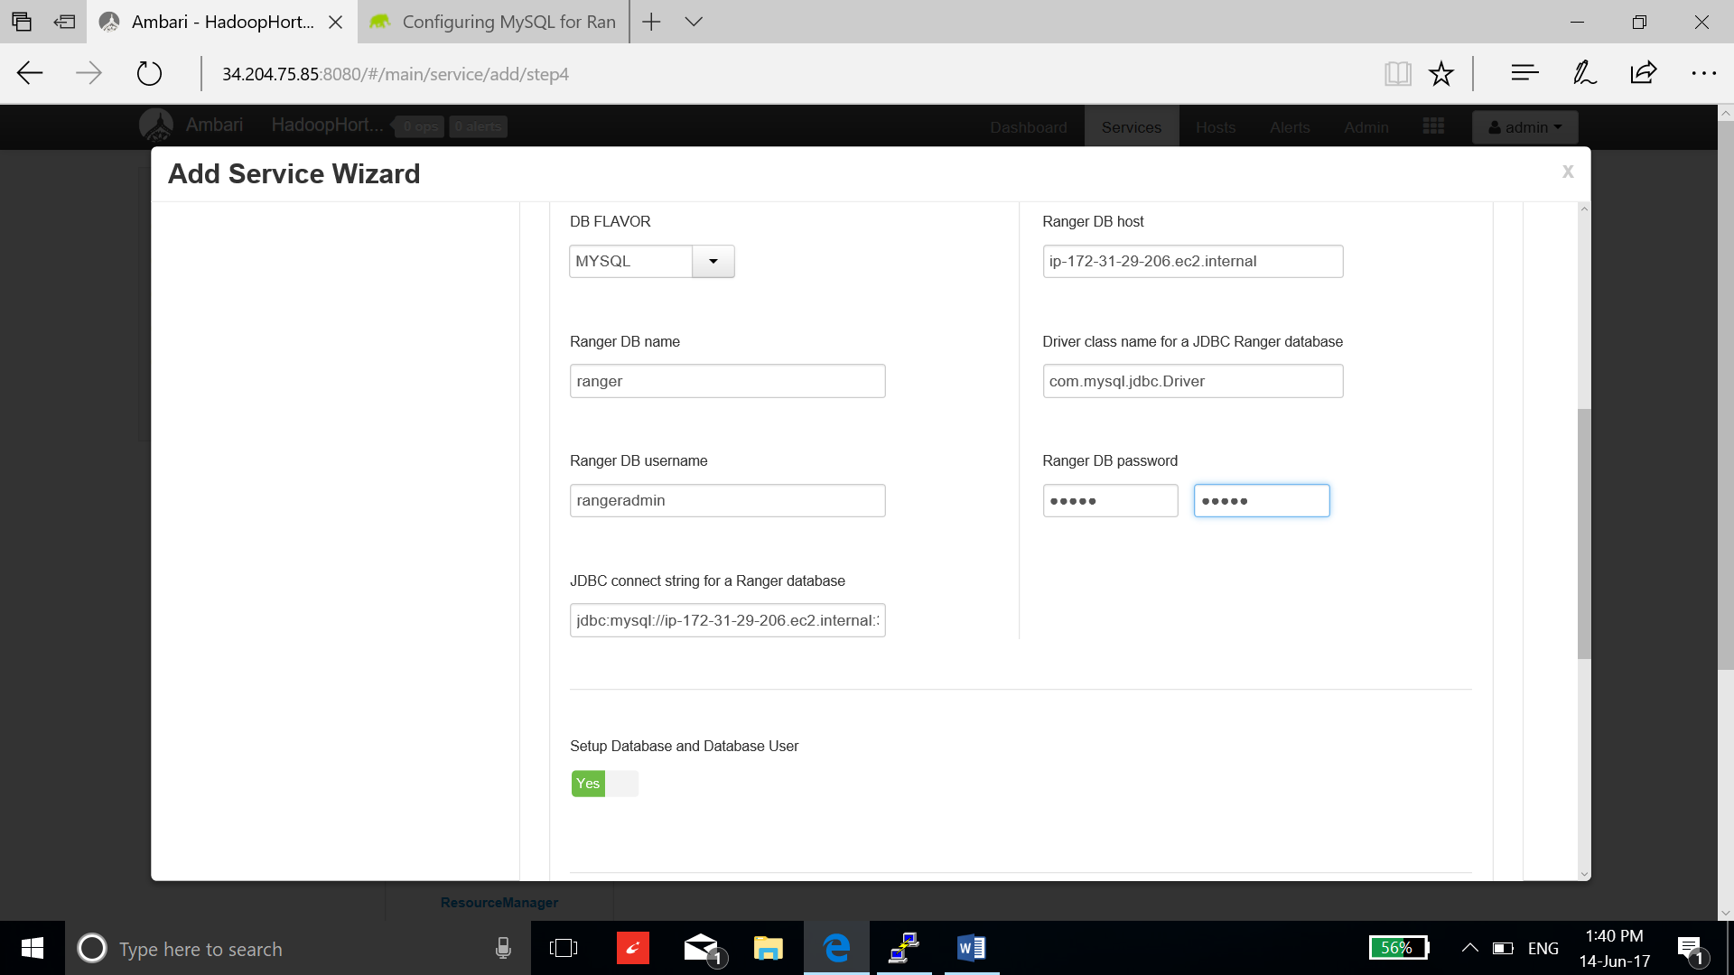

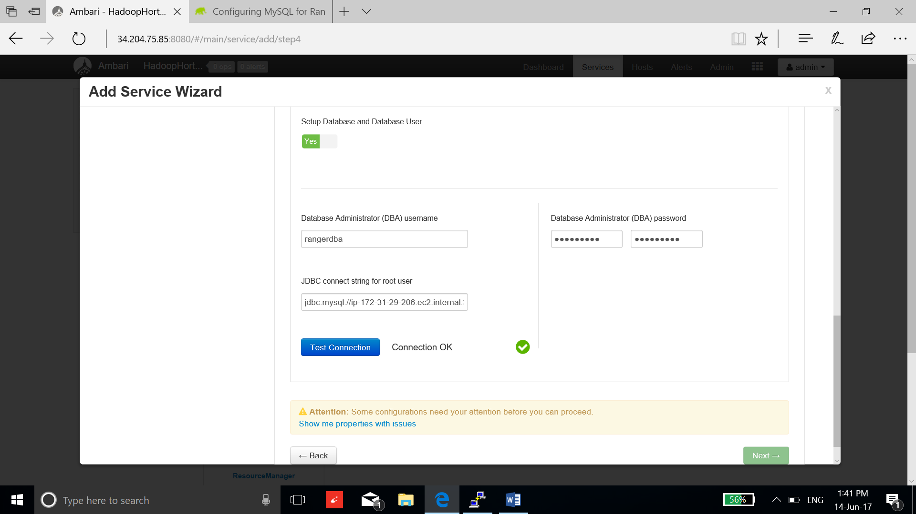

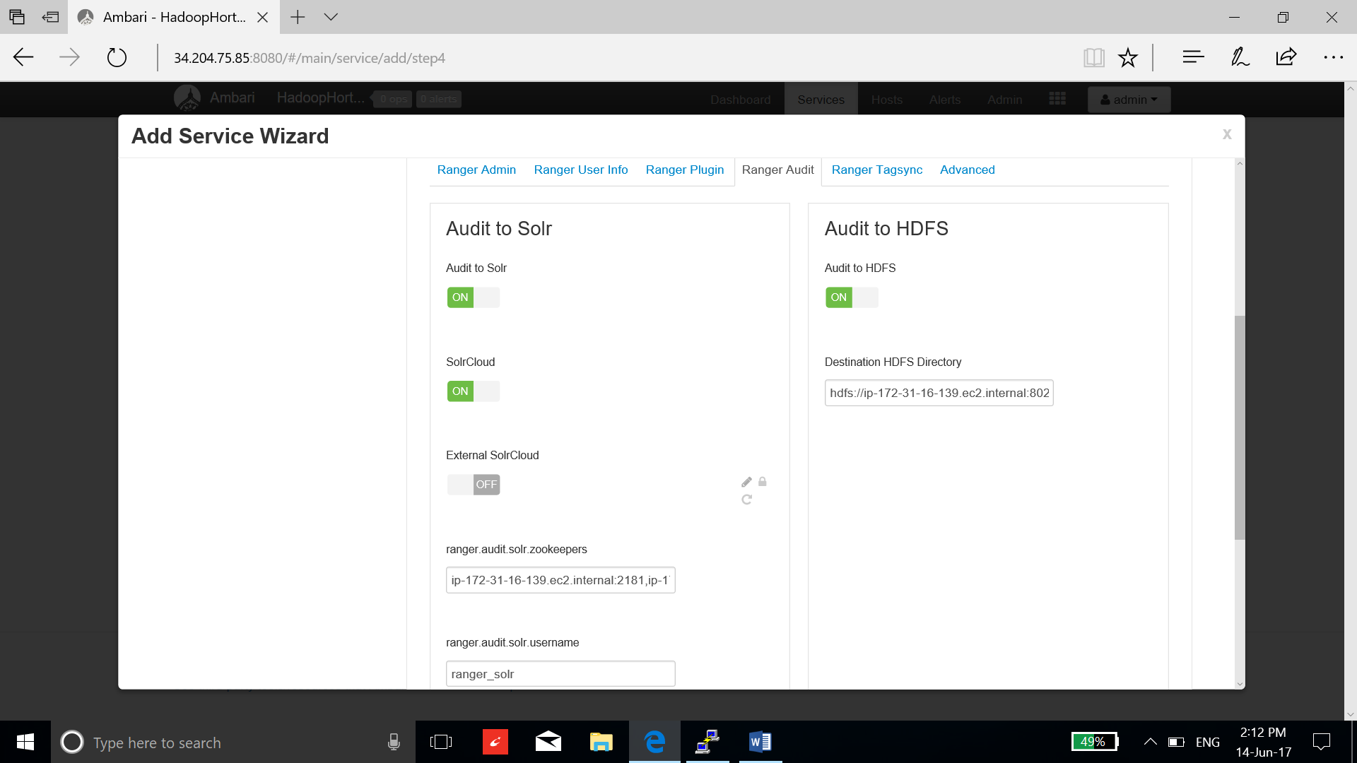

1. Now review and deploy service.

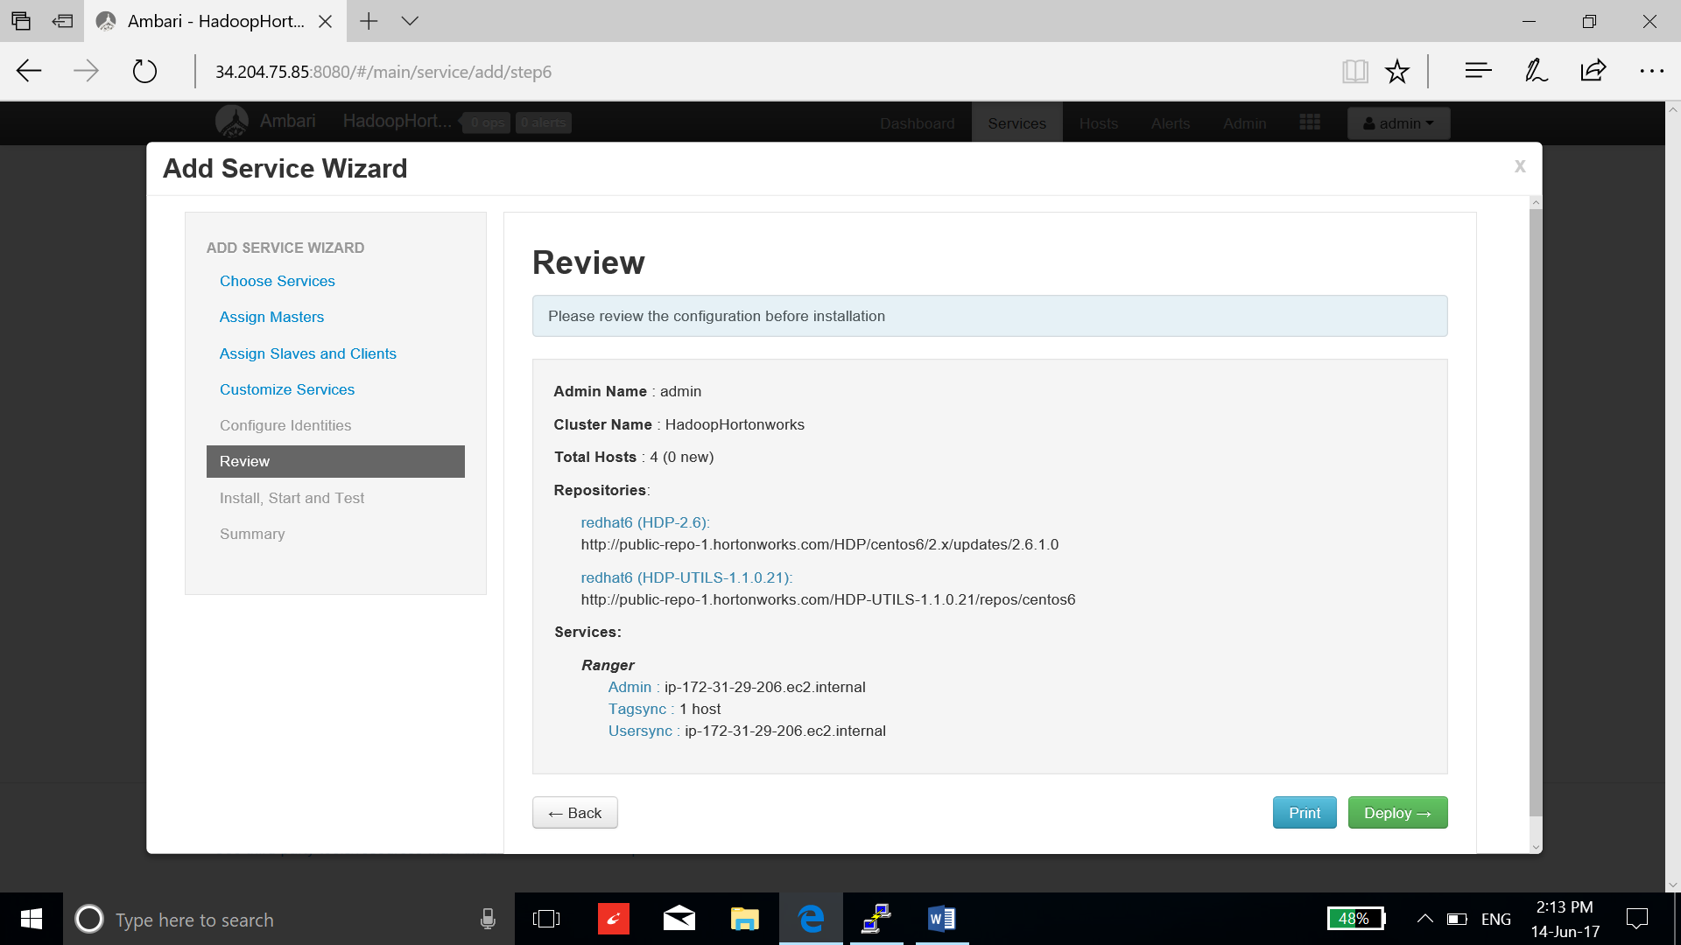

1. After the success of installation and startup, select the complete.

